8th Grade Warm-ups: April 10-14, 2017
Monday
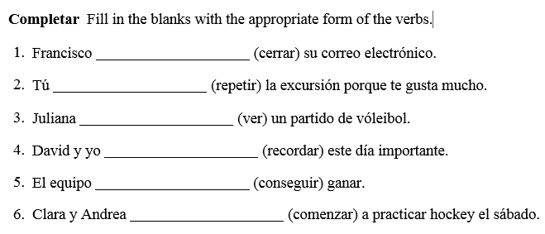
Tuesday
No warm-up (Computer lab)
Wednesday
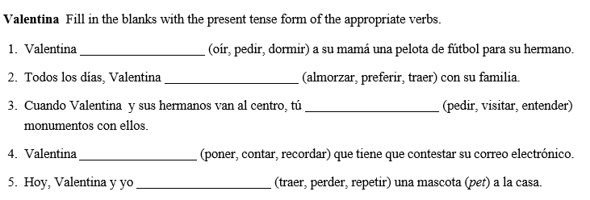
Thursday
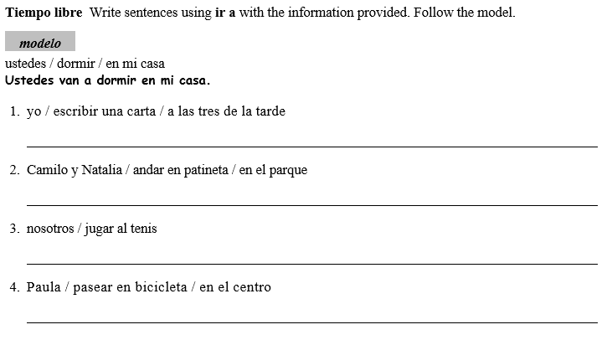
Friday
