8th Grade Warm-ups: January 30 – February 3, 2017
Monday 1/30/17
Translate:
1. To write an email
2. To climb mountains
3. To watch a movie
4. To play sports
5. To sun bathe

Tuesday 1/31/17
Translate:
- Weekend
- Fun activity
- Pastime
- Free time
- Sports

Wednesday 2/1/17
Translate:
- To write an e-mail
- To write a letter
- To read a newspaper
- To read a magazine
- To read an e-mail

Thursday 2/2/17
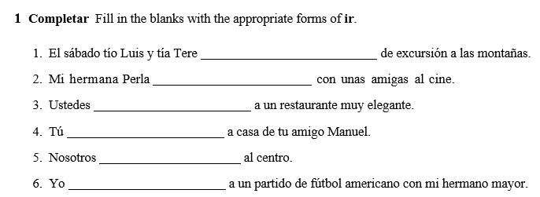
Friday 2/ 3/17
Translate:
- To skateboard
- To skate
- Skiing
- Water skiing
- To ski

