8th Grade Warm-ups: March 27-31, 2017
Monday
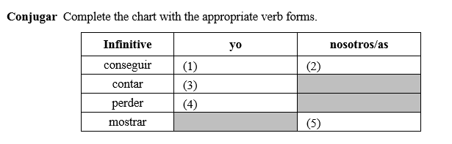
Tuesday
Translate the following:

- Ir
- Perder
- Poder
- Pedir
- Ganar
- Pensar
- Querer
- Almorzar

Wednesday
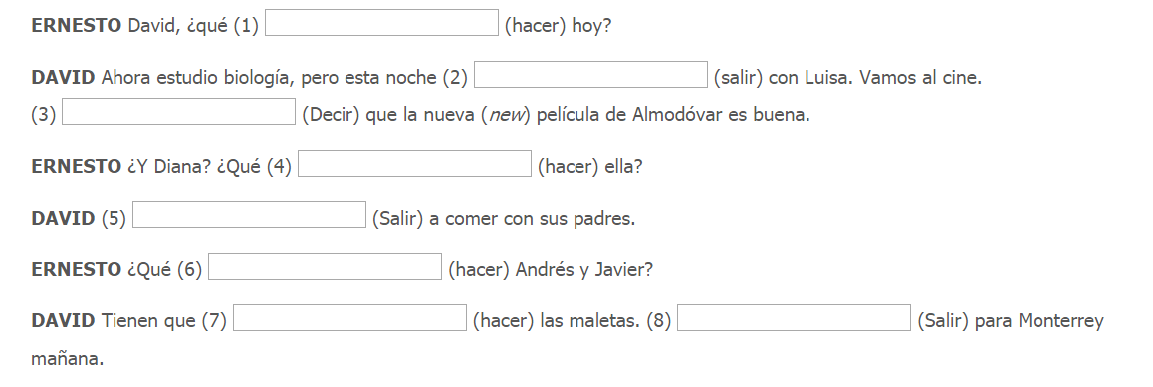
Thursday
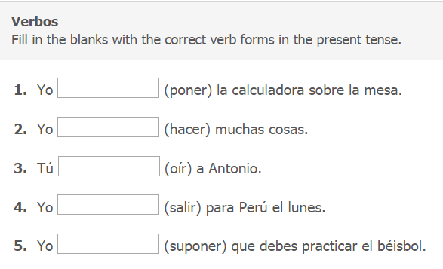
Friday
Translate the following:

- Hacer
- Poner
- Salir
- Suponer
- Traer
- Ver
- Oír

