8th Grade Warm-ups
February 27 – March 3, 2017

Monday February 27, 2017
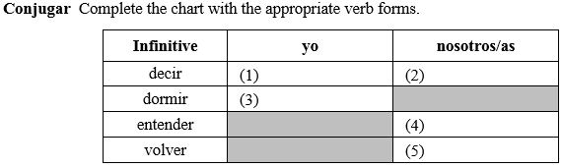

Tuesday February 28, 2017
Translate the following verbs and conjugate them in the YO form:

- IR
- CERRAR
- PENSAR
- QUERER
- DORMIR
- PODER

Wednesday March 1, 2017
Translate the following phrases:

- Escribir correos electrónicos
- Jugar vóleibol
- Ver películas
- Pasear en bicicleta
- Patinar
- Leer una revista
- Nadar
- Tomar el sol
- Bucear
- Escribir cartas
- Escuchar música

Thursday March 2, 2017
Translate the following verbs and conjugate them in the TU form:
- IR
- ALMORZAR
- PENSAR
- PERDER
- MOSTRAR

Friday March 3, 2017
Fill in the blanks with the appropriate form of the verbs.
- Francisco _________________ (cerrar) su correo electrónico.
- David y yo _________________ (recordar) este día importante.
- Clara y Andrea _________________ (comenzar) a practicar hockey el sábado.
- Tu _________________ (jugar) tenis todos los domingos.

