8th Grade Warm-ups – March 6-10, 2017
Monday March 6, 2017
Select the word that DOES NOT belong.
- Carta correo iglesia revista
- Parque deportivo café iglesia
- Ciclismo partido natación futbol
- Jugador centro museo plaza

Tuesday March 7, 2017
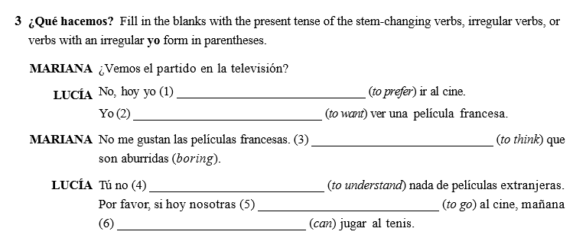

Wednesday March 8, 2017
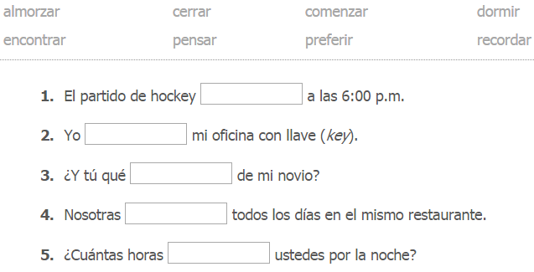
Thursday March 9, 2017
Conjugate the verb in parenthesis.
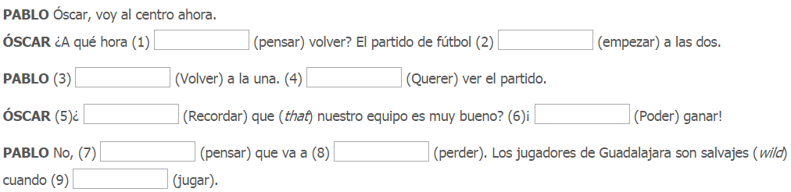

Friday March 10, 2017
