8th Grade Warm-ups
Janurary 23-27, 2017
Monday 1/23/2017
Answer the following questions based on the picture.
- ¿Es esta persona un atleta o un artista?
- ¿En qué tienes interés, en el ciclismo o en el tenis?
- ¿Es viejo? ¿Es delgado?
- ¿Tiene frío o calor?
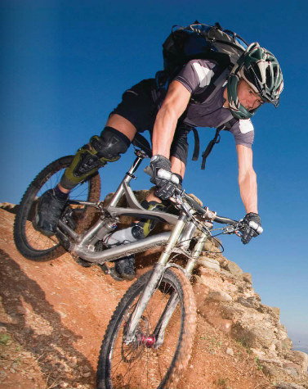

Tuesday 1/24/17
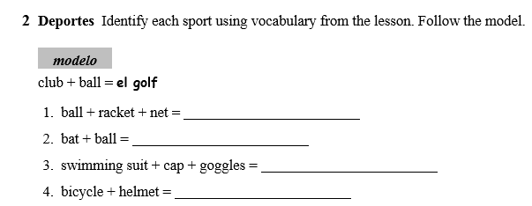

Wednesday 1/25/17
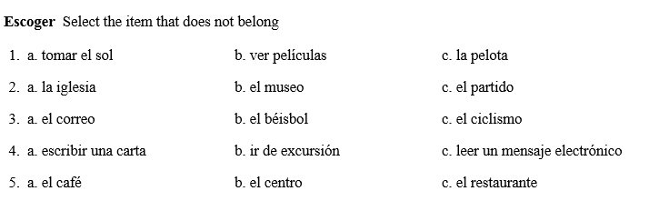

Thursday 1/26/17
Translate:
- Church, museum
- Downtown, park
- Cafe, restaurant
- Place, pool

Friday 1/27/17
Translate:
1. To skateboard
2. To scuba dive
3. To take a walk
4. To ride a bike
5. Free time
6. Pastimes

