Spanish Culture Web Quest
DIRECTIONS: Research information about the following holidays/festivals and answer the questions about them. Do NOT copy and paste.
La Tomatina
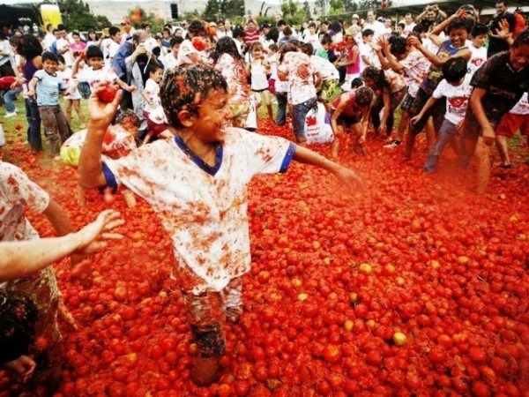

- Where does this holiday/event take place?

- When does it take place?

- Summarize what the holiday/event is about (minimum of 3 sentences).

Los Sanfermines
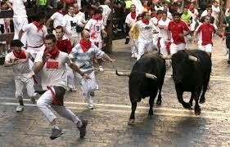
- Where does this holiday/event take place?

- When does it take place?

- Summarize what the holiday/event is about (minimum of 3 sentences).

La Feria Sevilla
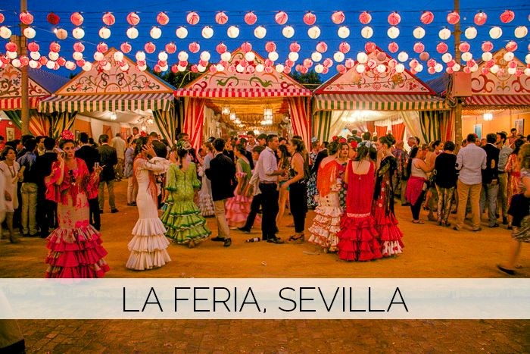
- Where does this holiday/event take place?

- When does it take place?

- Summarize what the holiday/event is about (minimum of 3 sentences).

Día de los Muertos
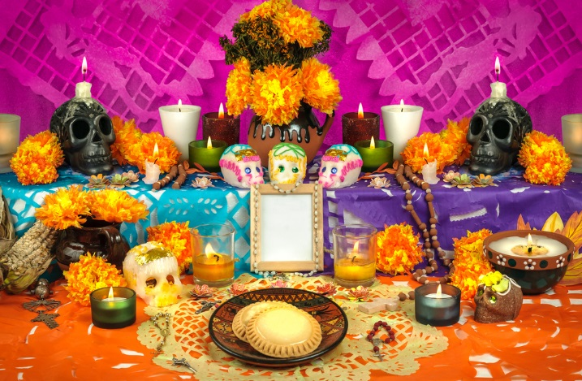
- Where does this holiday/event take place?

- When does it take place?

- Summarize what the holiday/event is about (minimum of 3 sentences).

Carnaval
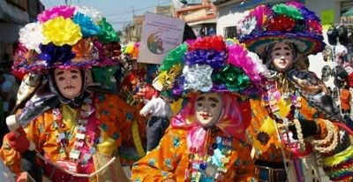
- Where does this holiday/event take place?

- When does it take place?

- Summarize what the holiday/event is about (minimum of 3 sentences).

El día de los reyes magos
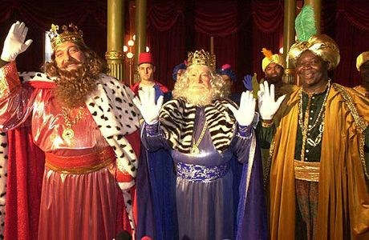
- Where does this holiday/event take place?

- When does it take place?

- Summarize what the holiday/event is about (minimum of 3 sentences).

**When you are finished, turn it in on Google Classroom**

